Pre-Physical/Occupational Therapy Club Syllabus: Spring 2021

Meet every other Thursday at 6 pm via Zoom
Click here for Zoom Link
Meeting ID: 924 4500 9989
Pass Code: 858462
1/28/2021 | Officer Introduction  Intro to PT + OT  T-shirt design
2/11/2021 | Club Dues +Shirt Voting Due  Therapist Guest Speaker
2/25/2021 | Grad School Tips  - Prereqs  - Interview  - Inside information  - GRE Prep
3/11/2021 | Grad School Admissions Guest Speaker
3/25/2021 | PNW Schools + Internship Opportunities  Intro officer election process
4/8/2021 | Officer Election
4/22/2021 | End of Semester Celebration

Join our club’s social media!
Facebook: @WSU Pre-PT/OT
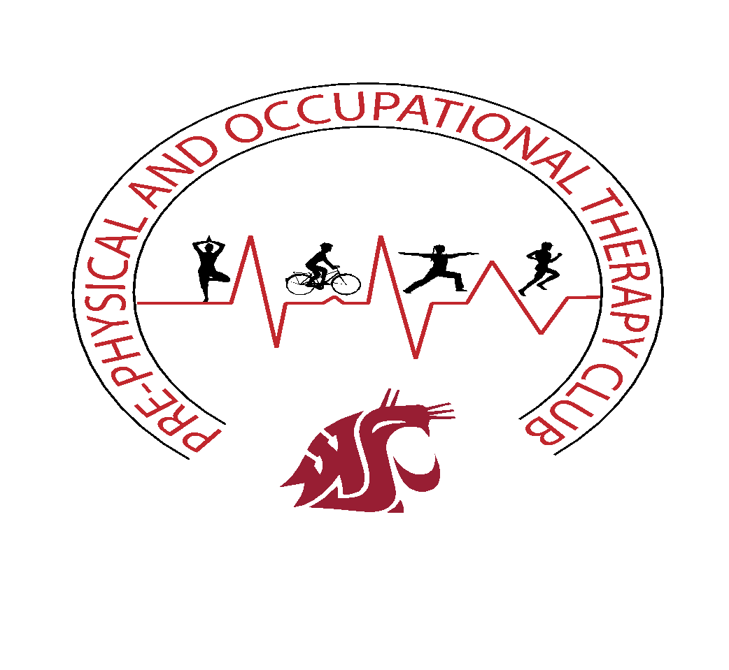
Instagram: @wsupreptot
For more information, contact our Facebook page or the Health Professions Student Center

Pre-PT/OT Advisor:
Dr. Donald Allison
Health Professions Student Center
Smith Center (CUE), Room 502
Pre-Health Advising Office, CUE 502,

